A Congregational Guide
for Disaster Preparedness and Response
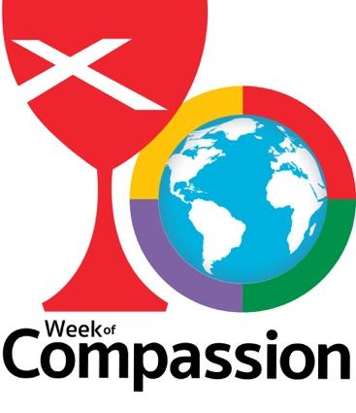

TABLE OF CONTENTS
SECTION 1-- Disaster Recovery: An Introduction
Welcome
Introduction
The Disaster Response Cycle
Long-Term Recovery Groups
The Role of The Church and Disciples of Christ Disaster Ministries

SECTION 2: Congregational Preparedness Plan
Why Prepare?
Creating Your Preparedness Plan

SECTION 3: Congregational Response Plan
Anticipating Response
Creating Your Response Plan

APPENDIX:
Risk Assessment
Facilities Inventory
Team Contact and Roles Form
Resources Inventory: Physical Structures
Resources Inventory: Capacity and Ministries
Resources Inventory: Equipment
Partners and External Resources
Recommended Resources
SECTION 1-- Disaster Recovery: An Introduction

WELCOME
This guide aims to help congregations think about disaster preparedness and response, in order to position themselves to serve their people and their greater communities in times of disaster. Thank you for taking this step to be a compassionate and helpful presence in moments of great need.

In Genesis 41, we encounter the story of Pharaoh’s dream of seven skinny cows devouring seven fat cows and seven good heads of grain replaced by seven scorched heads of grain. With divine insight, Joseph interprets the dream as a coming environmental calamity for Egypt and urges Pharaoh to take preparatory measures--specifically, creating emergency stores of grain during the years of abundance to be used during the years of famine.

A most remarkable part of the story of Pharaoh’s dream is how many people struggled to interpret the message. It’s really quite a simple dream made up of two fairly self-explanatory metaphors. Perhaps it was a kind of willful incomprehension on behalf of those who couldn’t (or wouldn’t) understand it. It was easier to feign ignorance than face the difficult reality.

Yet, Joseph and Pharaoh recognize the potential risk and harm it would do to their community, and they act. In so doing, they not only protect the people of Egypt during the seven years of famine that come, they also are in a position to help others. When Joseph’s brothers come to Egypt for assistance, since the drought and famine have struck in their land too, the Egyptian storehouses have enough for Joseph to share.

While we may not all have revelatory dreams of cows and grain, of coming disasters, we do have warning. In every place and context, we live at risk of emergency incidents and natural and human-caused disasters. The question is not if but when a disaster will strike and how severe the event will be. By considering in advance our risks and vulnerabilities, as well as our assets and resources, we can position ourselves and our congregations to be like Joseph: protecting and caring for our own people and offering assistance to our neighbors.

The goal of this guide--along with related trainings, webinars, and materials--is to enhance your congregation’s capacity to prepare for, respond to, and recover from natural and human-caused disasters, both large and small in scale. Hopefully, it will also help you understand the resources available to your congregation through our denominational ministries and through your local and regional ministries and relationships. We hope this guide and other available resources will:
- help congregations prepare for local and regional emergencies and disasters;
- increase the capacity of congregations to respond to such incidents; and,
- foster a network of cooperation with Disciples disaster-related ministries, between Disciples congregations, and between Disciples congregations and community and governmental organizations.

The chief deliverable of this guide is a step-by-step process to help each congregation create its own plans for dealing with disaster situations, including preparations for protecting physical property, caring for congregants, and responding to needs in the wider community after an emergency incident or disaster. In response to disasters, we have the opportunity to follow Jesus’ commands to love our neighbors as ourselves (Mark 12:31) and to give food, drink, shelter, and companionship to those who are in need (Matthew 25:35-40).

We want to extend special thanks to our partners at the International Orthodox Christian Charities for sharing the manual on which this guide is modeled. We thank, also, many of our other National VOAD partners who have shared resources and insights through the Preparedness Subcommittee.

INTRODUCTION

Disasters vary in scope and cause, and although there are similarities, all disasters are local. The International Red Cross’s definition of disaster informs the understanding of “disaster” in this guide: “A disaster is an event beyond the control of those affected causing great harm, suffering, or damage, and for which outside assistance is needed to sustain and rebuild the lives of those impacted.”

Some disasters are relatively small in scale, and communities are able to recover with only minimal assistance from outside organizations (e.g. apartment building fires, localized flooding, severe thunderstorms). In these instances, churches often play a vital role, since the resources found within the community are the main sources of assistance for affected individuals. Other disasters are complex and catastrophic and require substantial outside assistance, including information and guidance, material and financial donations, and volunteer labor.

Disasters, both large and small in scale, disrupt people’s lives and can cause emotional and spiritual upheaval. A network of support is necessary to help affected individuals recover. This network begins with First Responders--trained professionals such as firefighters, medical personnel, and emergency management officials--who address issues of immediate safety. From there, a combination of neighbors, faith communities, non-profits, governmental agencies, and other individuals and organizations provide services and resources to meet a wide variety of needs. Increasingly, faith communities are being called upon to play active roles from early response through long-term recovery. Because disaster recovery is a complex and often lengthy process, partnership is crucial!

THE DISASTER RESPONSE CYCLE

Every disaster is unique, and every community is unique, so it follows that every recovery is unique as well. Yet, despite the contextual and situational particularities, disaster recoveries tend to follow regular patterns and timelines. Specific needs may change, but the types of needs are fairly typical.

After the initial impact of a disaster, with the accompanying emergency response (evacuation, search and rescue, etc.), we can roughly categorize disaster responses into four phases: Relief, Assessment, Long-term Recovery, and Preparation or Mitigation. It can be helpful, too, to think about these phases as a continuum of activity and need.
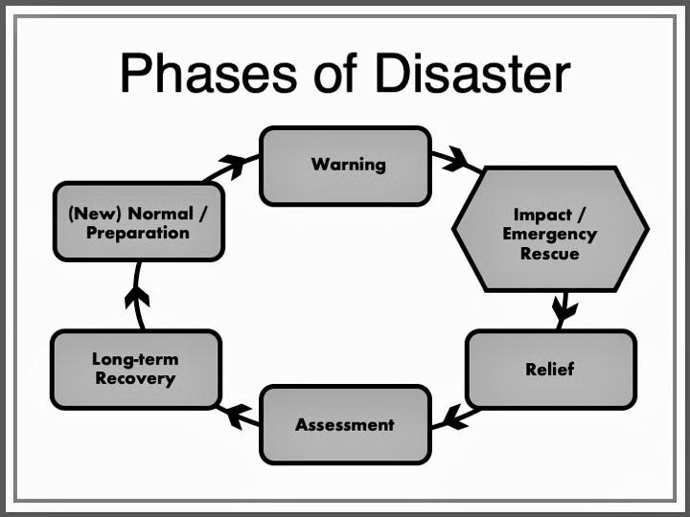
IMPACT: During the disaster itself, priority is on protecting life, safety, and property--in that order! Trained First Responders should take the lead. Heed the requests and warnings of Emergency Management officials to avoid putting yourself and others in harm’s way (and in a position of needed assistance or rescue, yourself). During this period, churches can be helpful in disseminating accurate information from Emergency Management officials and in checking on their members, especially those who may have limited access to warning messages or limited ability to seek safe shelter (due to issues of mobility, transportation, etc.).
RELIEF: Often within hours of impact, relief efforts begin. For disasters with significant advance notice, such as hurricanes, or prolonged disasters, such as wildfires or floods, relief efforts may begin in advance of the event itself. The priority during this phase is providing for basic human needs: food, water, safe shelter, medical needs, and emotional/spiritual needs. Sheltering, feeding, donations management, volunteer management, communications, and emotional/spiritual care are some of the main roles of voluntary organizations during this phase. In the later part of this phase, debris removal and clean-up become important roles for voluntary organizations as well. 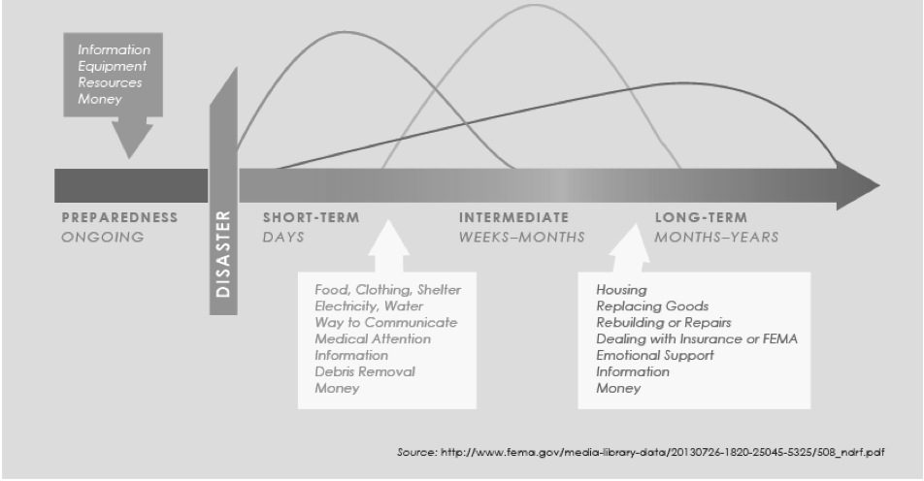
Figure 2
Figure 1

ASSESSMENT: Often the most frustrating phase of disaster recovery, the assessment phase is when households and communities are trying to take stock of damage, coordinate resources, file insurance claims, work with FEMA for individual and public assistance (in the case of a federally declared disaster), and make plans for strategic long-term response. As you can see in Figure 3, this phase coincides with a consistent decline in the energy and emotional state of communities. That is due, in part, to the natural timing of how people respond to traumatic events and, in part, to the frustrations of feeling like recovery is stalling. During this phase, important work happens; it is just typically not very visible and mostly happens in meetings and through paperwork. Emotional and spiritual care, damage and needs assessments, disaster case management, legal assistance and assistance with program registrations, and participation in community recovery planning are key activities for voluntary organizations during the Assessment phase. During this phase, the disparities between folks with resources and folks without sufficient resources to recovery become more apparent. Advocacy can be another important role during this phase, to promote equity in recovery and to use recovery resources to improve rather than exacerbate inequalities in a community.
LONG-TERM RECOVERY: This phase is the longest part of an active disaster response (hence the name, long-term recovery). For moderate- to large-scale disaster this phase typically takes years. During this phase, a community is establishing a new “normal.” The repair or replacement of housing is a primary element of this phase, along with continued emotional and spiritual care needs, restoration of livelihoods and local economies, and replacement of lost goods. The denominational ministries of the Christian Church (Disciples of Christ) involved in disaster response typically invest most heavily in long-term recovery, through volunteer efforts for repair and rebuild and funding support for long-term recovery groups (see figure 4).
PREPARATION/MITIGATION: This is ideally less of a phase and more of a way of existence for communities! We should always be anticipating future events by assessing hazards and risks and taking steps to mitigate against and prepare for them. During long-term recovery, if communities cast their vision far enough, they will incorporate preparation and mitigation into their recovery plans (e.g. elevating homes during rebuilding to protect against future floods).
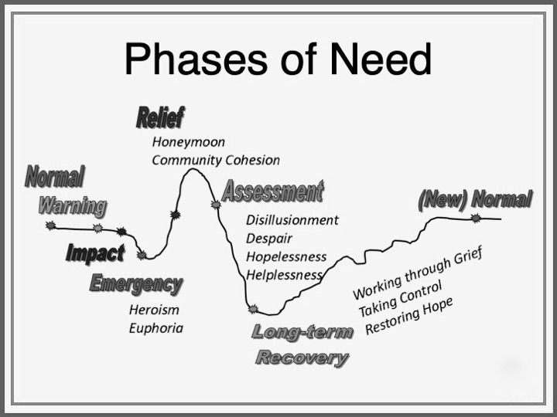

Figure 3
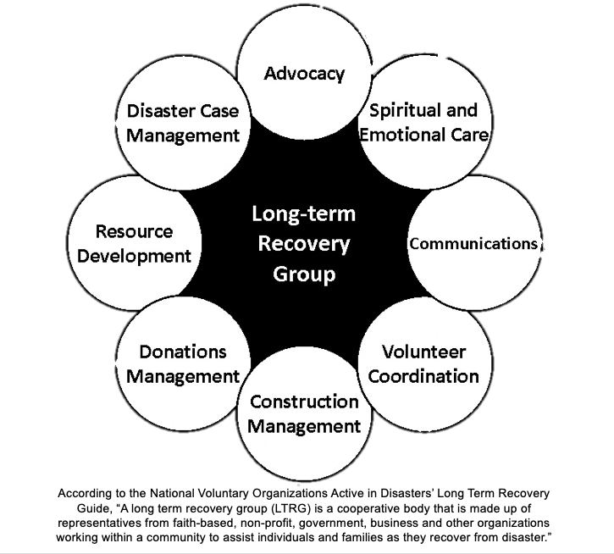

THE ROLE OF THE CHURCH

Houses of worship are uniquely positioned to assist their communities through every phase of the disaster cycle. They can encourage preparedness, respond quickly to emergent needs, and accompany communities through the long process of recovery. Churches and other houses of worship bring a unique combination of relationships and expertise to disaster recovery. Local congregations serve as centers of connection and can play a vital role in identifying needs and communicating resources. Because congregations are rooted in communities prior to and long after disasters, they have pre-established trust with survivors and a vested interested in their long-term recovery. Additionally, denominational or affiliated disaster recovery ministries and organizations add to those relationships the specialized knowledge and experience specific to disaster recovery as well as financial resources, human capital, and practical models and guidelines.

Faith communities are particularly well-suited to do the following:
- Offer the language of faith, hope, and solidarity in the wake of traumatic events;
- Connect members of the community to available services and resources;
- Mobilize material, social, volunteer, and spiritual resources over the long term;
- Advocate for and with vulnerable populations to promote equitable recovery;
- Offer a safe place for survivors to deal with the frightening and sometimes overwhelming emotions and experiences that accompany a disaster.

The Christian Church (Disciples of Christ) has two primary denominational ministries for disaster response and several other denominational ministries that offer resources after crisis events:

- Week of Compassion-- as the relief, refugee, and development mission fund for the Christian Church (Disciples of Christ), Week of Compassion works with partners to alleviate suffering throughout the world. One aspect of this ministry is engaging Disciples in disaster response in the United States and Canada. Week of Compassion works through local Disciples congregations and Regions, as well as through a network of other disaster response organizations. The primary role of Week of Compassion is as a conduit of resources-- financial, pastoral, and informational--by communicating with Disciples, providing grant funding to congregations and partners, and connecting Disciples with disaster recovery volunteer opportunities.
- National Benevolent Association-- as the health and social service ministry of the Christian Church (Disciples of Christ), NBA helps provide emotional and mental health support to communities following disasters in the United States and Canada. When a disaster has a significant impact on Disciples, NBA partners with Week of Compassion, Regions, and local congregations to assist and equip clergy and lay leaders to care for themselves and their communities.
- Pension Fund-- through the Ministerial Relief fund, the Pension Fund of the Christian Church provides aid to Disciples ministers facing large, unexpected expenses, including those incurred following disasters.
- Disciples Church Extension Fund-- In addition to providing building and capital planning services, fundraising consultations, and loans for capital projects, Disciples Church Extension Fund offers consultation services to congregations that suffer damage to their buildings during disasters.

In addition to the denominational ministries, individual congregations within the Christian Church (Disciples of Christ) respond to disasters in myriad ways, drawing on their unique gifts, strengths, and relationships. This guide will hopefully assist your congregation in thinking through how you can best respond and how the denominational ministries can support you!

SECTION 2: Congregational Preparedness Plan

WHY PREPARE?
As the old saying goes, an ounce of prevention is worth a pound of cure. Or, for the more sports-minded, the best offense is a good defense. Multiple studies have confirmed that investments in preparedness and mitigation demonstrate significant return on investment. A report from the National Institute of Building Sciences measured that for every $1 spent through federally funded mitigation projects in the United States, communities saved between $4 and $6, and every $1 spent meeting building codes in the United States saved communities $11. Preparedness plans can also help ensure the safety of people. Simple actions like installing and testing smoke alarms save thousands of lives every year. Similarly, improvements to emergency alert systems and evacuation plans make communities far safer in the event of a disaster.

In addition to the practical benefits of preparation, communities of faith have an additional motivation: advance planning and preparation helps us help others. In the critical moments, days, and months following a crisis event, established plans can save precious time and resources and can make responses more efficient. To return to the lesson of the scripture in the introduction of this guide (Genesis 41), it was only because Egypt had planned and prepared for the famine that they had ample stores of grain to share with Joseph’s brothers when they arrived seeking aid.

CREATE YOUR PREPAREDNESS PLAN:
The steps below will help your congregation create a basic preparedness plan.
- Gather Your Team
- Assess Current Plans
- Conduct Risk Assessment
- Conduct Facility Inventory
- Conduct an Operational Assessment
- Develop Your Plan
- Communicate Your Plan

Step 1: Gathering Your Team
Disaster preparedness and response should not be the responsibility of a single individual. The needs are simple too great in most emergency situations. The size of your team will depend on the size of your congregation. It should include some key leaders in the congregation who are familiar with the property and the strengths and needs of the membership, as well as individuals who have a particular interest or aptitude for disaster preparedness and response. (You might adjust or expand your team after completing the Resources Inventory: Capacity and Ministries found in the Appendix.)

Step 2: Assess Current Plans
Consider what efforts your congregation has made for preparedness in the past. Are there plans for evacuation and sheltering in place? Are there plans for communicating other emergent situations (e.g. prayer chains, contact lists assigned by elder, text or phone alerts for weather closings)? Gather any related paperwork, such as past continuity of operations plans, records of any past disaster responses, insurance documents, building inspections, and congregational directories.

Step 3: Conduct Risk Assessment
Using the Risk Assessment tool found in the Appendix, consider what the most likely events are for your congregation. In the assessment tool, you multiply the potential impact by the likelihood that an event will happen--this can help you prioritize as you make plans. A major earthquake might have extreme effects on persons, property, and operations, but if the probability of having an earthquake in your area is 0, you can save yourself the time and effort of planning for that particular event! Consider exploring resources from your state, county, and municipal emergency management offices to get a more detailed portrait of likely hazards in your area.

As you consider the various events in the risk assessment, do not focus solely on the highest total risk scores. Some events may have low to moderate impact but are also relatively easy to prepare for. Extreme heat, for example, is not likely to have significant impact on property, but can affect people and potentially your operations. Steps to prepare might be a plan for how to open as a cooling center or communicate the availability of other centers, how to communicate a facility closure if necessary, and how to check on members of your congregation who are vulnerable to heat.

Step 4. Conduct Facility Inventory
Keeping your most likely risks in mind, do a thorough walk-through of your facilities, using the Facility Inventory found in the Appendix. You might divide your team into smaller groups and assign each group a section of the property. The inventory is comprised of 3 parts: the facility structures, facility safety equipment, and facility assets.

For the facility asset inventory, you may want to contact your insurance company, as they may ask for additional details in the event these items are included in a claim. We encourage you to take pictures or video to document these assets, including their location and, if applicable, the model or serial number of the item. (You may already have a similar inventory for insurance purposes; if so, use this as an opportunity to review and update that information.)

If a parsonage is part of the church facilities, any assets in the parsonage belonging to the church (such as appliances) should be included in the inventory.

It is also important to have an inventory of any important documents that are stored at the church facility, such as insurance documents, deeds or leases, employment and tax paperwork, records of bequests or endowment, financial records, and baptismal records.

As part of this inventory, you may want to consider what items could and should be removed from the church facility for safe-keeping in advance of a disaster, in cases where there is sufficient warning. Create a plan for where these items could go and who would be responsible for their removal, storage, and return.

Step 5. Conduct an Operational Assessment
Consider the following, first under normal circumstances and then how they would be affected in the event of a disaster. When you have identified critical programs, assess what processes would need to be in place for them to continue to function.
- What are the primary activities of our congregation? (include worship, study, outreach, and activities that take place in your facilities but are operated by others)
  - What of these programs are critical?
  - What services do these activities provide to the community?
  - What activities would be most important to maintain or resume following a disaster?
  - What facilities are necessary for these activities?
- How does our congregation function as an organization?
  - Who has authority to make decisions about facilities use, finances, and other operational functions?
  - What staff, materials, and procedures are necessary to maintain operations?
  - How does payroll function?
  - How are donations received, processed, and documented?

Step 6. Develop Your Plan
Now that you have assessed your facilities and operations, make a plan (or plans) for how the church will improve its preparedness and how it will operate following a disaster. This might include the following--
- Mitigation Plan: Include steps can you take to reduce the risk of damage to the church property and to reduce the risk of operational paralysis following a disaster.
- Emergency Action Plan: Include actions that should be taken just before (if there is warning) or immediately after a disaster to prevent loss of life and property and to promote fast recovery. Make a checklist.
- Communications Plan: Detail who will be contacted, under what circumstances, how, and for what purpose. Consider updating the church directory with alternative and emergency contact information for congregants.
- Continuity of Ministry: Plan for continuation, growth/adjustment, or suspension of existing programs, activities, and services. (Part 3 of this guide will help you flesh out this part of your plan, especially for ministries that will grow/adjust to meet disaster-specific needs.)

Step 7. Communicate Your Plan
A plan that sits on a shelf does nobody any good! Share this plan with the congregation: through key leaders or groups, through congregational meetings or board meetings, through the newsletter or other church communication platforms, and through other creative avenues! We encourage you to share your plan with your Regional Minister as well.

SECTION 3: Congregational Response Plan
ANTICIPATING RESPONSE
(something about flexibility; have a plan, but also hold it loosely in order to respond to emergent needs; something about partnership; something about denominational resources)

CREATE YOUR RESPONSE PLAN
- Gather Your Team
- Review Risk Assessment
- Identify Internal and External Resources
- Create Action Plan
- Communicate Your Plan

Step 1: Gather Your Team
You might simply continue with team that worked on preparedness, or you may choose to reconfigure your team to involve people with specific disaster response skills. One way to organize your team is by roles/responsibilities following a disaster (communication, facilities, finances, etc.). A key to your team functioning well in the aftermath of a disaster is a clear plan for communication and decision-making, so however you organize your team, be sure to define those processes. The Team Contact Information and Roles document in the Appendix can help.

Step 2: Review Risk Assessment
In part 2 of this guide, analysis of the risk assessment (found in the Appendix) focused on the potential impact a disaster would have on your congregation. In this section, consider the various events and risks as they relate to your wider community. For example, your church may not be at risk for flooding, but the neighborhood down the hill is within the 100-year flood plain.

Take some time, also, to think about populations in your community who might have particular needs in a disaster. This might include those with limited mobility, individuals with physical or cognitive disabilities, immigrant communities or communities where English is not the primary language, folks experiencing homelessness, elderly folks, children, poor communities, and historically under-represented communities/communities of color.

Multiple studies have indicated that disasters affect communities in disproportionate ways, with people of color, poor people, and socially vulnerable populations being more likely to be directly affected by the disaster and less likely to access sufficient resources to recover. Consider how risks might vary across various populations in your community. In Step 3, when you complete the Resource Inventory: Partnerships and External Relationships, think about how your congregation is connected with and in relationship with these populations.

Step 3: Identify Internal and External Resources
The needs following disasters can be overwhelming, and trying to find where your congregation fits into the vast landscape of response can be a daunting task. We suggest you start from the existing strengths and resources of your congregation. From there, seek out partnerships that will help you understand who else is active in your community and coordinate your efforts with others. The Resource Inventories found in the Appendix can help you think through the gifts your congregation brings.

For the purposes of this guide, we have identified four types of resources to consider:
- Physical structures
- Equipment
- Capacities and Ministries
- Partnerships and External Resources

Physical Structures:
While a growing number of churches now meet in non-traditional and rented spaces, the majority of Disciples congregation still maintain some physical property. These spaces can function as gathering spaces, shelter, donation storage, and sanctuary following disasters.

Some questions to keep in mind along with the resource inventories in the Appendix:
- Do you have space that can be converted into a shelter for persons temporarily mandated to leave their homes or those who have lost their homes in a natural or human-caused disaster?
- Do you have sufficient restroom facilities for people who would be housed at the parish or using the parish for other activities?
- Do you have vehicles that might be used to transport evacuees to shelters or first aid centers, and so on?
- Do you have snow-removal equipment or portable pumps or related items that can be used in a weather emergency?
- Do you have office space and equipment that might be used as a communications center or satellite in an emergency?
- Do you have a commercial kitchen that could be used to prepare and serve or deliver meals for neighbors?
Equipment:
Use the “Resource Inventory: Equipment” document in the Appendix to consider what tools, vehicles, and other equipment you have at your disposal, either because the church owns them or congregants would be willing to loan them for use after a disaster. Include any vehicles and trailers the church owns. If you are part of a night-shelter program, do you have cots or mattresses available? Do you have kitchen supplies--including flatware, dishes, grills, pots and pans, and tables and chairs--that would be useful for a mass-feeding effort? Do you have awnings or tents that could be used at outdoor reception centers or to provide shade for volunteers? Do members of your congregation have utility vehicles, trailers, or heavy-duty equipment (backhoes, tractors, etc.)?
As you make an inventory of these items, think through how that equipment would be stored, managed, and tracked. Consider whether there are liability concerns with usage (especially for vehicles and heavy equipment). Make a plan for how you will determine who is permitted to use church equipment or loaned equipment from congregants.
Capacities and Ministries:
Some of our most valuable resources are our people!
Consider who in your congregation has skills or expertise that could be put to use following a disaster. Some of those skills might include language fluency, IT, construction, hospitality, logistics, or fundraising. Others may have professional training in counseling, medical care, childcare, law enforcement, law, or architecture. Still others may have valuable relationships with government, social service agencies, advocacy organizations, or foundations.
Use the “Resource Inventory: Capacities and Ministries” document in the Appendix to help you canvas your congregation.

The Capacities and Ministries inventory will also help you consider what activities and ministries in your congregation could have a disaster-response application. Do you have a food pantry or clothing closet? Perhaps a parish nurse program or health screenings? May you host youth mentorship groups, a preschool, or after-school tutoring. Some ministries have fairly obvious correlations to disaster response needs, while others might need to adapt to new needs. For example, a regularly scheduled back-to-school or holiday craft fair might be expanded into a disaster recovery resource fair.

Partnerships and External Resources:
Disaster recovery is fundamentally a community process, and stronger collaboration between public, private, non-profit, and faith-based groups means a more effective and efficient recovery. Many new relationships and partnerships will grow out of a disaster recovery (including some unexpected ones!), but if there are strong relationships across a community prior to a disaster, it makes the coordination of recovery that much simpler.

Local ministerial alliances are often a good starting point for collaboration, as are many local emergency management offices. Consider what social service and non-profit agencies you work with regularly. Schools, nursing homes, and hospitals are also good places to continue fostering relationships.

The Voluntary Organizations Active in Disaster (VOAD) network is one avenue for building disaster-specific partnerships. As the name suggestions, VOAD is made up of a wide variety of non-profit organizations that specialize in supporting disaster response. The Christian Church (Disciples of Christ) is a member of National VOAD--through Week of Compassion, as well as several state VOADs--through our Regions. The mission of VOAD is to provide a forum promoting cooperation, communication, coordination and collaboration; to foster more effective delivery of services to communities affected by disaster. (Visit www.nvoad.org for more information.)
The “Resource Inventory: Partnerships and External Resources” in the Appendix has a list of potential partners to get you started, but it is certainly on an exhaustive list. Think creatively!
Step 4: Create Your Action Plan
Based on the assessments and inventories you have created, start drafting a plan for how your congregation could respond following a disaster. Discuss potential plans with other community partners and emergency management officials. Keep in mind that your plan should be a living document that changes along with your ministries, partnerships, and capacities. Remember, too, that your plan is a guide not a rulebook! Disaster responses require flexibility, and even the most well-designed plans may require on-the-spot adjustment for you to meet the real needs of your community.

Step 5: Communicate Your Plan
Hopefully your team has been providing updates to and involving your congregation in the full process of developing your preparedness and response plans! If not, be sure to communicate the plan now. Consider also sharing your plan with your colleagues, Regional Minister, and Week of Compassion so they can be better prepared to help you implement your plan in the event of a disaster. Sharing your resource inventories as well can help the Regional Office and Week of Compassion coordinate with your congregation in responding to disasters.

Week of Compassion Associate Director for Domestic Disaster Response:
Rev. Caroline Hamilton-Arnold; caroline@weekofcompassion.org 203-772-8597

APPENDIX: Risk Assessment
Evaluate the likelihood and potential severity among the following possible emergency events using the scale below. Assume each event occurs at the worst possible time (i.e. during peak gathering times). You will need to consider these factors:

HUMAN IMPACT | PROPERTY IMPACT | OPERATIONAL IMPACT | PROBABILITY
Possibility of death or injury to your staff or your members | Physical losses and damages to your facility and/or vehicles | Interruption of services | Likelihood this event will occur

Rank the probably and impact of the following events. High=3 Moderate=2 Low=1 None=0

To calculate “TOTAL RISK”: For each event, add the three IMPACT columns together, then multiply the total by the PROBABILITY. (For the EXAMPLE EVENT, the IMPACT columns total 7; the probability is 2; 7x2=14)

Possible Emergency Events | HUMAN IMPACT | PROPERTY IMPACT | OPERA-TIONAL IMPACT | PROBABILITY | Total  Risk
EXAMPLE EVENT | 3 | 1 | 3 | 2 | 14
Extreme Temps – Cold

Extreme Temps - Heat

Thunderstorm

Tornado/Straight line winds
Severe winter storm

Flood

Earthquake

Fire

Volcanic Activity

Medical – Infectious disease (e.g. Pandemic Influenza)
Mass casualty

Possible Emergency Events | HUMAN IMPACT | PROPERTY IMPACT | WORK-FLOW IMPACT | PROBABILITY | Risk
Extended Power Outage
Landslide/Mudslide

Labor Action/Civil Disobedience

Water Contamination or shortage
HAZMAT (chemical spill)
Radiological

Terrorism

Train derailment

Other:

Other:

Other:

Other:

Score Ranges:
High Risk=19-27 Moderate Risk=10-18 Low Risk=1-9 No Risk=0

The most probable events for our organization are:
The events with the greatest potential impact for our organization are:
The events that pose the greatest total risk for our organization are:
The following events are, therefore, of greatest concern for our organization:

Check with your state and local emergency management offices for information about the most likely events for your area.

APPENDIX: Facilities Inventory Consider filing this with your insurance documents or including insurance policy information on this inventory.

PART 1: Facility Information
Address:
Street City State ZIP County

Facility Campus Size: Number of Buildings on Campus:

[for each building on campus]
Building Name
Building Construction Type (wood, brick, etc.)
Building Size (number of floors, square footage, capacity)
Year of Construction
Number of Rooms
Number of Exits (specify ADA)

PART 2: Facility Safety

Item | Location(s) | Inspection Schedule
Fire Alarms/Smoke Detectors
Fire Suppression/Sprinklers
Fire Extinguishers
AED
Security Alarm/Cameras
Generator
First Aid Kit
Flashlights/Emergency Lighting
Exit Signs
Water Shut-off
Electrical Breakers
Gas Shut-off

Church records and backup copies (insurance, financial documents, membership information, etc.) are stored in the following locations:
The following people have keys or passwords to access records:

PART 3: Facility Assets

Item | Description & Serial Number | Location | Warranty & Insurance Info | Value

Examples:
Communion service sets Furniture
Stained glass windows Exterior amenities such as crosses or signs
Pew Bibles and hymnals Instruments and sound equipment
Kitchen appliances Memorial or historic items
APPENDIX: Team Contact Information and Roles
Pastor | Responsibilities in Prep & Response Plan
Name:
Cell phone:
Landline:
Address:
Email Address:
Likely Evacuation Location:

Emergency Contact:

Team Lead | Responsibilities in Prep & Response Plan
Name:
Cell phone:
Landline:
Address:
Email Address:
Likely Evacuation Location:

Emergency Contact:

Team Member | Responsibilities in Prep & Response Plan
Name:
Cell phone:
Landline:
Address:
Email Address:
Likely Evacuation Location:

Emergency Contact:

Team Member | Responsibilities in Prep & Response Plan
Name:
Cell phone:
Landline:
Address:
Email Address:
Likely Evacuation Location:

Emergency Contact:

APPENDIX: Resources Inventory: Capacity and Ministries
List ongoing ministries in your congregation that could be utilized during an emergency. (e.g. food pantry, clothing bank, daycare or after-school program, grief support groups)

Ministry | Description | Point of Contact

List congregants who have specialized skills/expertise that could be useful in responding to a disaster. (e.g. medical professionals, First Responders, communications, logistics, HAM Radio operators, mental health professionals, government officials, legal professionals, childcare, construction, NIMS training, CERT/NERT training)

Name | Areas of Skill | Contact Information

APPENDIX: Resources Inventory: Equipment
List all equipment available for use in a disaster response (e.g. vehicles, boats, tools, generators, cots, HAM Radios, trailers, tables, dishes, dollies/hand-trucks, computers, childcare supplies). Consider including congregant-owned resources that could be used by the church.

Equipment | Description and Quantity | Location

APPENDIX: Partners and External Resources
List denominational, ecumenical, and community organizations you could partner or coordinate with in a disaster. Include governmental agencies, local non-profits, and other key relationships.

Denominational | Main activities and relationship | Point of Contact
Week of Compassion | Informational support, solidarity grants for affected households and churches, grants for relief and long-term recovery | Caroline Hamilton-Arnold, Associate Director for Domestic Disaster Response, caroline@weekofcompassion.org 203-772-8597
Disciples Church Extension Fund | Assist church leaders in securing damaged buildings, navigating insurance and construction, addressing legal concerns | Jim Michel  jmichel@disciplescef.org  317.635.6500 Ext. 2535
Pension Fund | Ministerial Relief Fund provides financial assistance to clergy affected by disasters | Matt Rosine  mrosine@pensionfund.org  317-713-2718
Regional Office/Minister | Pastoral support, connection to Regional relationships and resources, communication support
Ecumenical | Main activities and relationship | Point of Contact
Emergency Services | Main activities and relationship | Point of Contact
Social Service Agencies | Main activities and relationship | Point of Contact
Businesses | Main activities and relationship | Point of Contact
Schools | Main activities and relationship | Point of Contact
Local Government | Main activities and relationship | Point of Contact
Social/Fraternal Orgs | Main activities and relationship | Point of Contact
Other | Main activities and relationship | Point of Contact

APPENDIX: Recommended Resources
INFORMATIONAL:
www.Ready.Gov -- The Department of Homeland Security has compiled many resources for individual and community preparedness. Resources are searchable by type of disaster and include resources for families and children.

http://redd.tamu.edu -- Project REDD: Texas A&M University’s Center on Disability and Development has a variety of resources about unique needs during disasters of people with disabilities or access and functional needs.
http://www.n-din.org/ndin_resources/ndin_tips_sheets_v1208.php -- The National Disaster Interfaiths Network has many tip-sheets and other resources available, specifically designed for religious leaders.

http://www.n-din.org/ndin_trainings/t4t_EFCDC1-1.php -- Among the National Disaster Interfaiths Network resources is information about the importance of religious and cultural literacy in the context of disaster response and recovery.

https://vimeo.com/321809906 Deaf Link worked with FEMA and other Long-Term Recovery partners to create informational videos for the Deaf and hard of hearing community.

https://www.uccfiles.com/pdf/A-Disaster-Preparedness-Manual-for-Churches.pdf Our partners at the United Church of Christ Disaster Ministries have created a congregational preparedness guide, with excellent disaster-specific checklists created in collaboration with The Insurance Board.

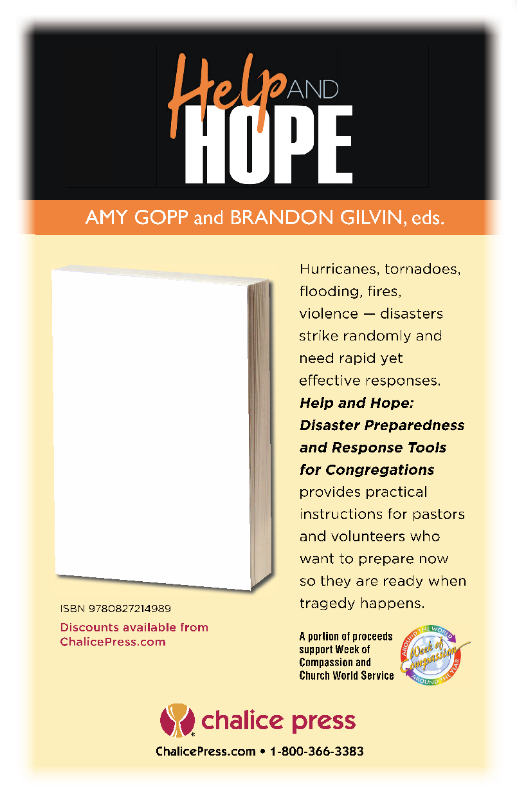
TRAININGS:
https://training.fema.gov/is/ -- FEMA offers a range of Independent Study Courses, on topics from Fundamentals of Emergency Management to What to do in an Active Shooter Situation.

http://www.brethren.org/cds/volunteer/ -- Children’s Disaster Services, a Week of Compassion partner through Brethren Disaster Ministries, offers trainings for volunteers to support children in evacuation shelters and disaster response centers.

https://www.redcross.org/take-a-class/disaster-training -- The American Red Cross offers a variety of disaster response trainings through their local offices.

https://www.dsf.edu/replay-past-webinars -- Disciples Seminary Foundation hosted a webinar on congregational disaster preparedness, led by Rev. Caroline Hamilton-Arnold. A recording of the webinar is available for free.

